# MODULE 02 Computer Forensics Investigation Process LAB SCREENSHOTS

Lara Alofi

2110886

Y

Computer Hacking Forensic Investigator (CHFI)

Lab Session Identifiers

1. <https://eccouncil.learnondemand.net/Lab/Launch/65580?AssignmentId=1454946&lang=>

Username on EC-Council System

1. 2110886@uj.edu.sa

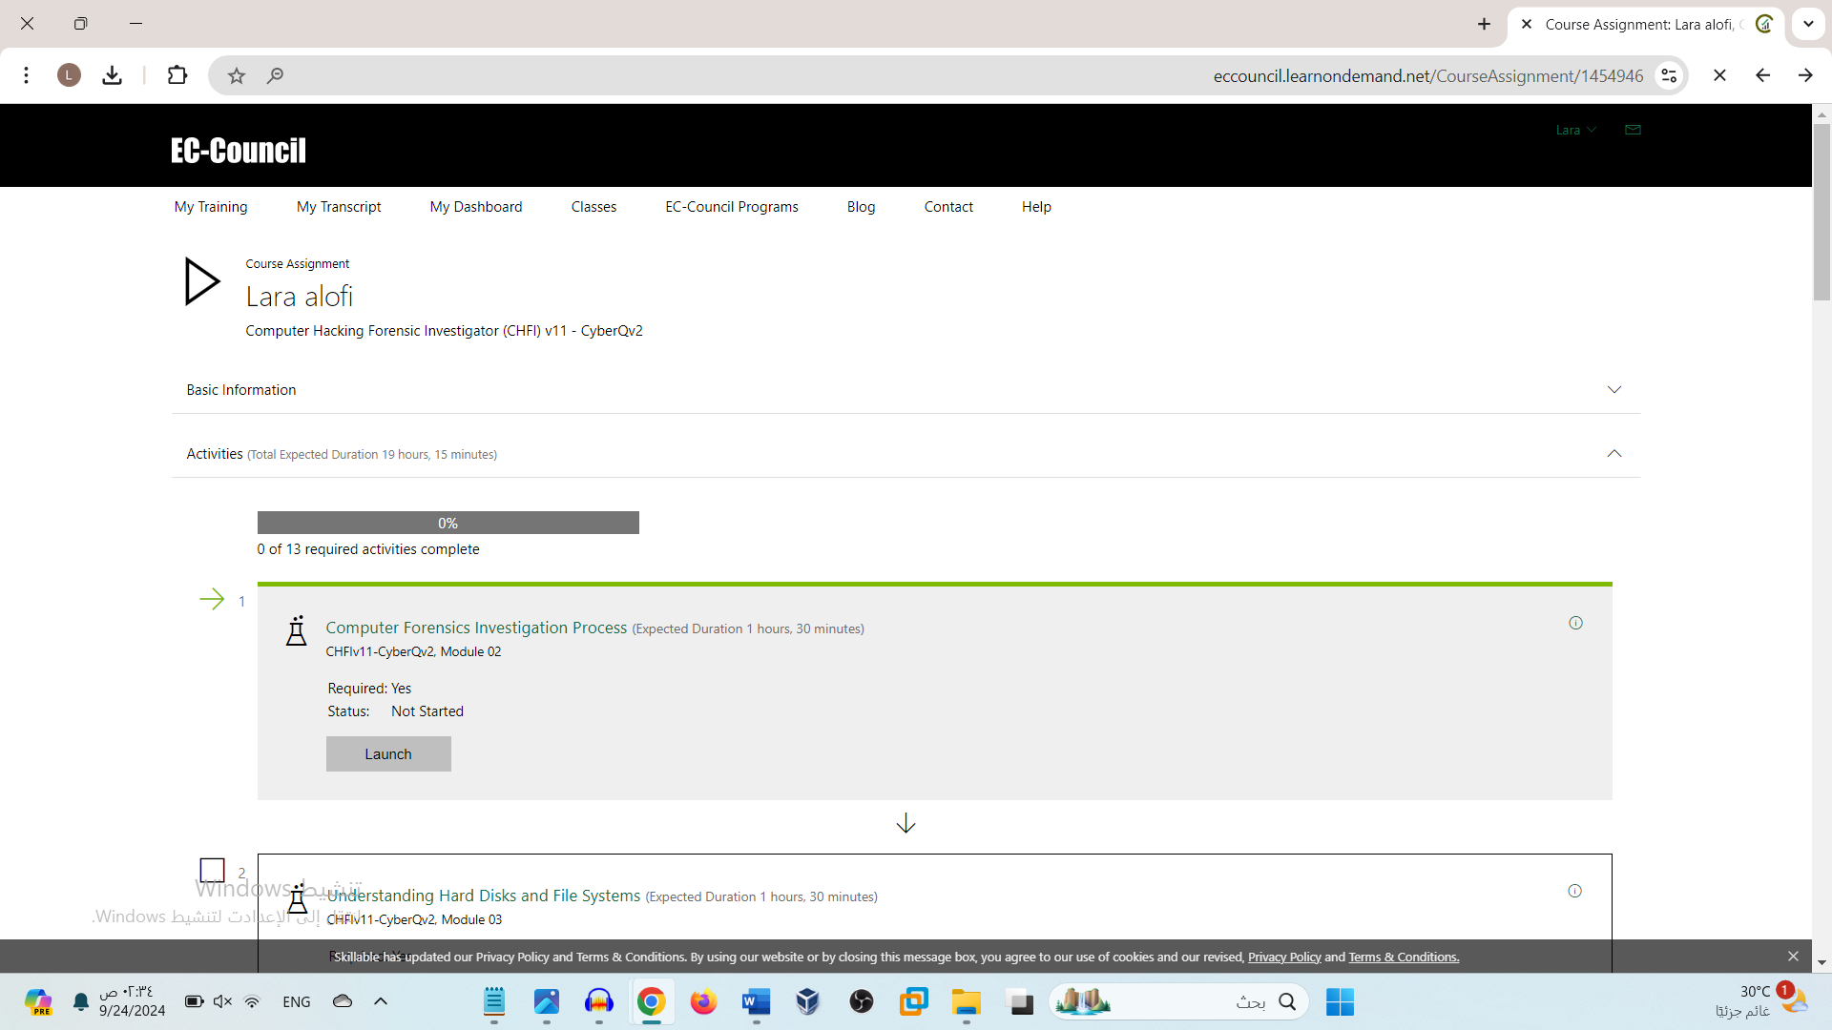

Lab 01

Lab 02

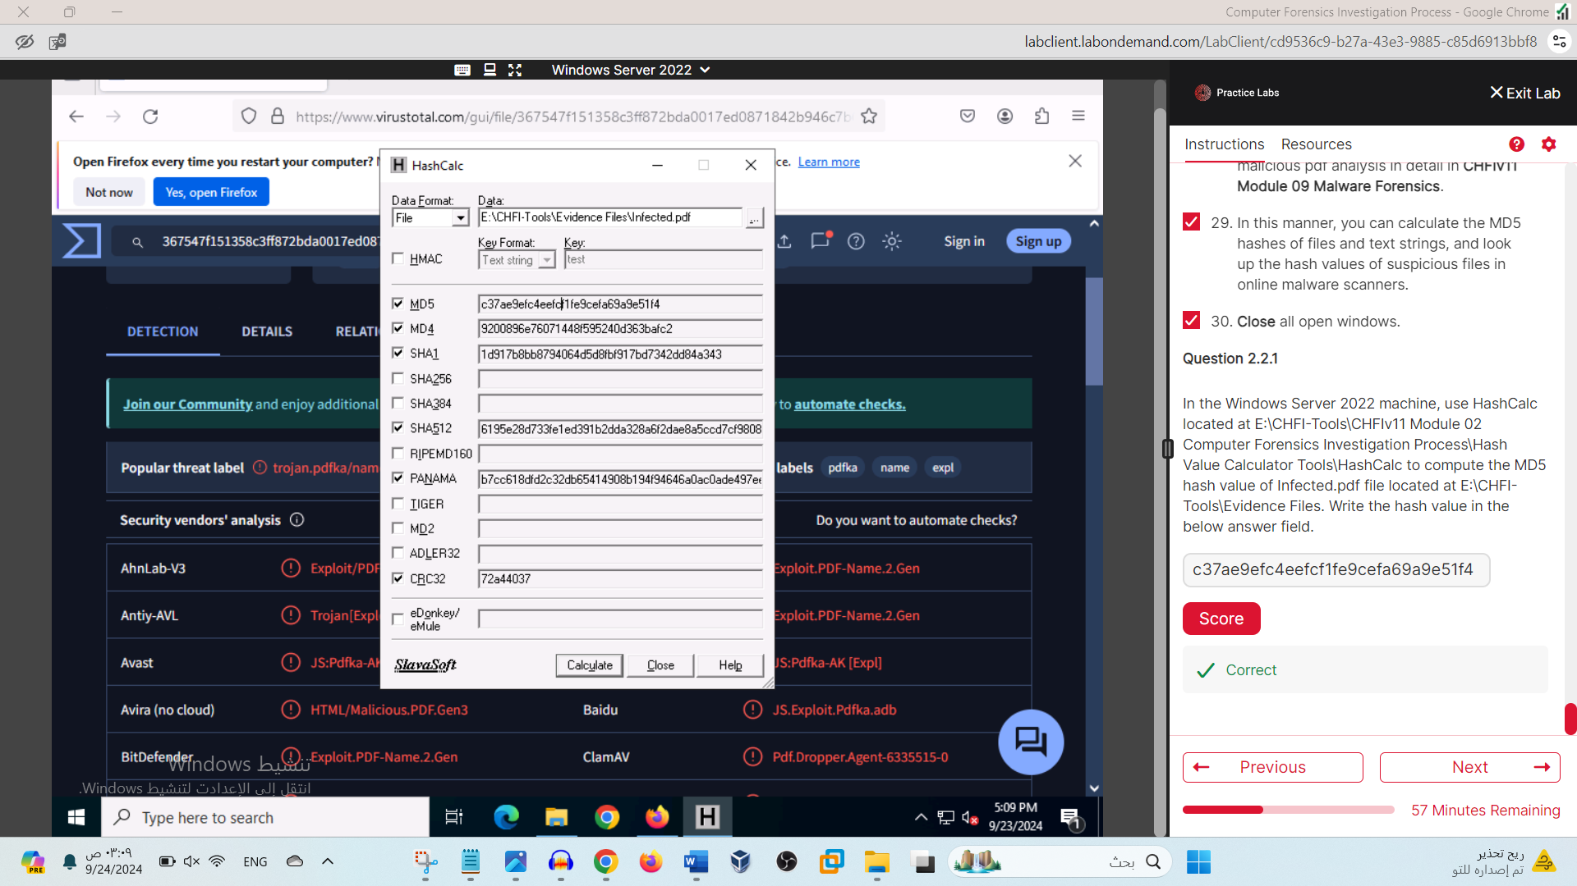

Lab 03

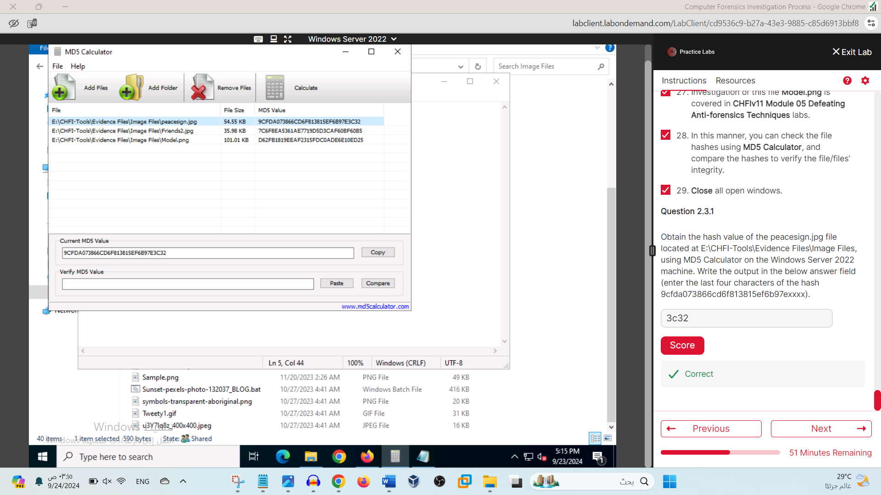

Lab 04

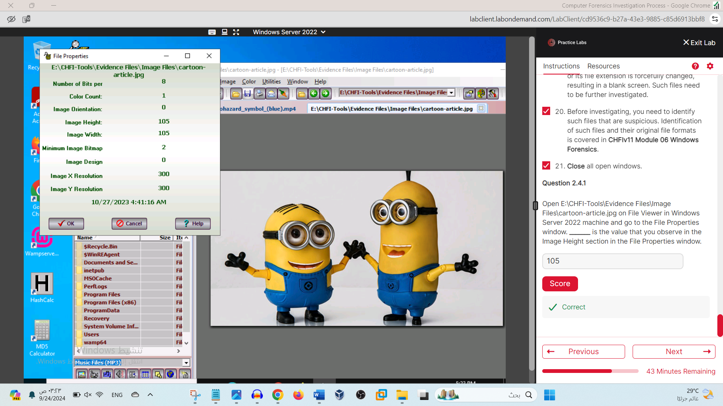

Lab 05

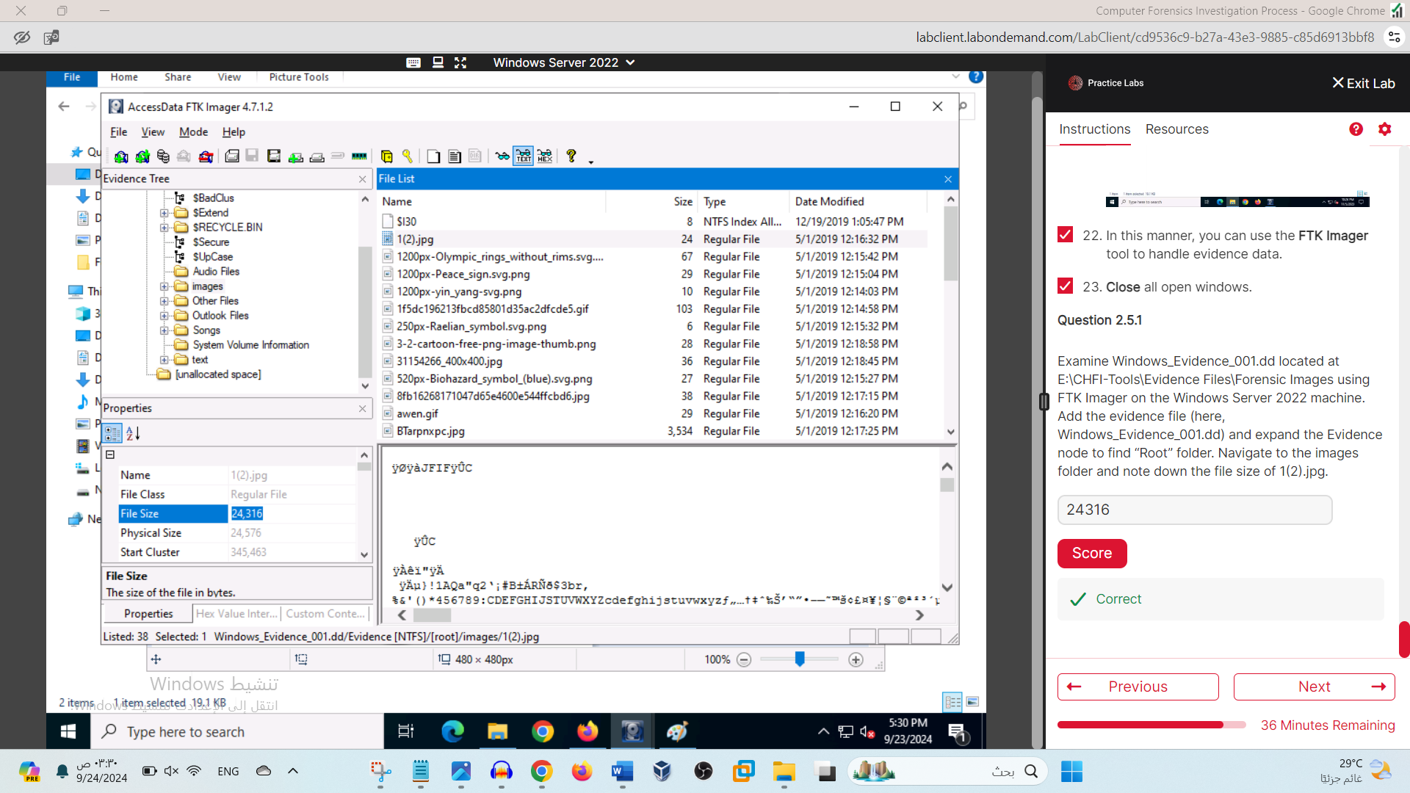

Lab 06



